1. **Problem definition and description**

The main purpose of the project is to find a pattern in the concentration of Beijing PM2.5 by applying wavelet transform in every 1-year cycle. Due to the result, the effectiveness of the transform in terms of dimensionality reduction would be discussed.

1. **Core code**

# Draw signal graph

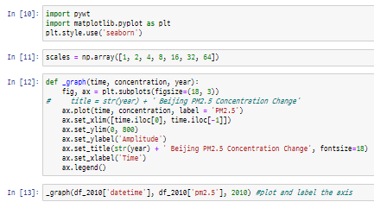

# Perform wavelet transform and draw the graph

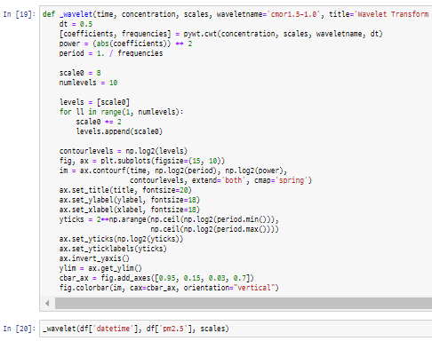

1. **Results and plots**

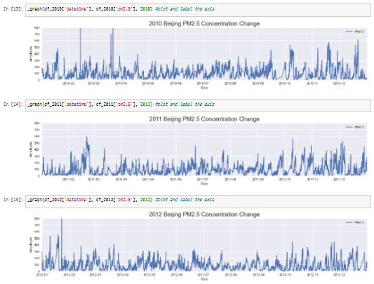 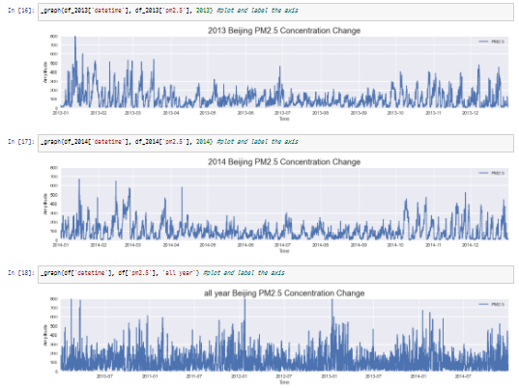

**Figure 1. Plotting of the signal of each year**

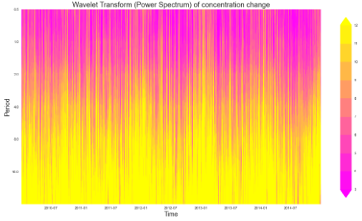

**Figure 2. Result of the wavelet transform**

1. **Discussion**

**Basic observation of the concentration changes by year**: According to Figure 1, Beijing PM2.5 concentration fluctuations were drawn by year. In the year range 2010 to 2014, the year 2013 would have the most severe fine dust problem. Plus, we could see that the highest concentration of PM2.5 would like to appear during the late Autumn to Winter, and relatively low during the late Spring to Summer.

**Results of the transform**: According to Figure 2, we can see that most of the power is concentrated in an 8 to 16 period. Plus, we can regularly see the highest fluctuation of PM2.5 during the winter seasons, which would yield the same result with the basic observation that we conducted with the normal graph. It is marked in light blue box. Since the year around 2012 and 2013 would have more yellow color, we could figure out that the power of PM2.5 (the fine dust problem) was stronger (was severe) than the other years.

**The meaning of the wavelet transforms & why continuous wavelet transforms**:

Wavelet transform was suggested to overcome the limit of Fourier transform. Since the Fourier transform transforms a signal from the time domain to the frequency domain, it compresses the whole frequency into the same time domain. In other words, if the frequency varies by time, Fourier transform cannot express its variance. Therefore, Wavelet transform allows us to figure out what kinds of frequency exist in which exact time points by analyzing it with small window called ‘scale’. This is called ‘convolution’.

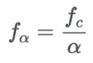

And those scales correspond to frequencies: for smaller scales to detect better high frequencies and for bigger scales to detect better low frequencies. It is said that for time series, fine scales should be selected for better transform: therefore, continuous wavelet transform was selected instead of discrete wavelet transform.

**Results and Dimensionality reduction**: Likewise with the Fourier transforms, wavelet transforms are needed to figure out the main components of the signal and its power of contribution to compose a signal. But the main difference with Fourier transform was that wavelet transform perform ‘convolution’, which would finely distinguish different kinds of frequencies by time.

1. **Refernces**